

ANJALAI AMMAL MAHALINGAM
ENGINEERING COLLEGE
SWIFT SHIP TRACKER
Team ID : SWTID-2026-2516
Team Leader : ARUN ADHITHYA G - adhithyaarun574@gmail.com
Team member : ABINAYA N S - snabipavi@gmail.com
Team member : ATCHAYA P - atchayaponnusamyk@gmail.com
Team member : AARTHIKA P - yuvasri.p24@gmail.com
Team member : NAVEEN S - snaveen1234vpm@gmail.com
PROJECT REPORT

TABLE OF CONTENTS
Section | Page
1. Abstract | 3
2. Problem Statement | 3
3. Objectives | 3
4. Scope and User Personas | 4
5. Technology Stack | 4
6. Data Model | 4
7. Implementation | 5
8. Testing and Results | 8
9. Challenges and Learnings | 8
10. Limitations and Future Scope | 9
11. Conclusion | 9
12. References | 9

1. Abstract
SwiftShip Tracker is a Salesforce-based parcel management project focused on organizing parcel records, delivery status updates, tracking lookup, notification automation, and operational monitoring in one environment. The project uses custom Salesforce objects for parcels, deliveries, senders, and receivers, together with Flow Builder, Apex automation, reports, and dashboards. A sample parcel record demonstrates status and estimated-delivery management. A record-triggered flow sends a parcel status notification, while an autolaunched tracking flow retrieves parcel details by tracking number. Apex trigger and batch automation support synchronization of delivery estimates, with a unit test confirming the batch test case passes. The project also includes an operations dashboard. Customer-facing conversational AI and a public portal were planned but were not verified or completed.

2. Problem Statement
Customers often face delays and confusion while booking, tracking, and managing parcel deliveries because they need to call support or use multiple apps. A conversational AI agent can simplify this by letting customers book parcels, get live tracking, and manage deliveries in one place.

3. Objectives
- Gather requirements from end users and delivery agents.
- Define system scope and personas (Customer, Agent, Admin).
- Design a data model with relationships between Parcel, Sender, Receiver, and Delivery.
- Identify use cases: parcel booking, tracking, and delivery update automation.
- Use Salesforce Flows, Apex, reports and dashboards; Prompt Builder and Agentforce were planned tools.

4. Scope and User Personas
Persona | Needs / Responsibilities
Customer | Book parcels, track deliveries, and manage delivery information through a simplified experience.
Agent | Update parcel delivery status and work with parcel records and operational processes.
Admin | Manage the Salesforce solution, access controls, automation, and operational information.

5. Technology Stack
Technology / Component | Use in SwiftShip Tracker
Salesforce Developer Edition org | Platform used to build and demonstrate the solution.
Custom objects | Parcel__c, Delivery__c, Sender__c, and Receiver__c.
Lightning record pages | User interface for viewing and managing parcel records.
Flow Builder | Record-triggered and autolaunched flows for notification and tracking.
Apex | Trigger, batch class, and test class for delivery-estimate synchronization.
Reports and Dashboards | Operational reporting and the SwiftShip Operations Overview dashboard.
Permission sets | Agent permission set and supporting access configuration.

6. Data Model
Object | Key Fields / Relationship
Parcel__c | Name (tracking number, e.g. PAR-00001), Status__c, Weight__c, Estimated_Delivery__c; lookups to Sender and Receiver.
Delivery__c | Related to Parcel__c; has its own Estimated_Delivery__c.
Sender__c | Sender information linked to Parcel__c.
Receiver__c | Receiver information linked to Parcel__c.

The data model connects Sender and Receiver records to Parcel records through lookups. Parcel is related to Delivery, allowing delivery information and estimated-delivery dates to be associated with the shipment.

7. Implementation

7.1 Parcel Record and Status Management
Agents update the Status field on a parcel record. The sample parcel used in the demonstration is PAR-00001, with an estimated delivery date of 10/10/2026. The status picklist supports Booked, Picked Up, In Transit, Out for Delivery, Delivered, Delayed, and Cancelled.
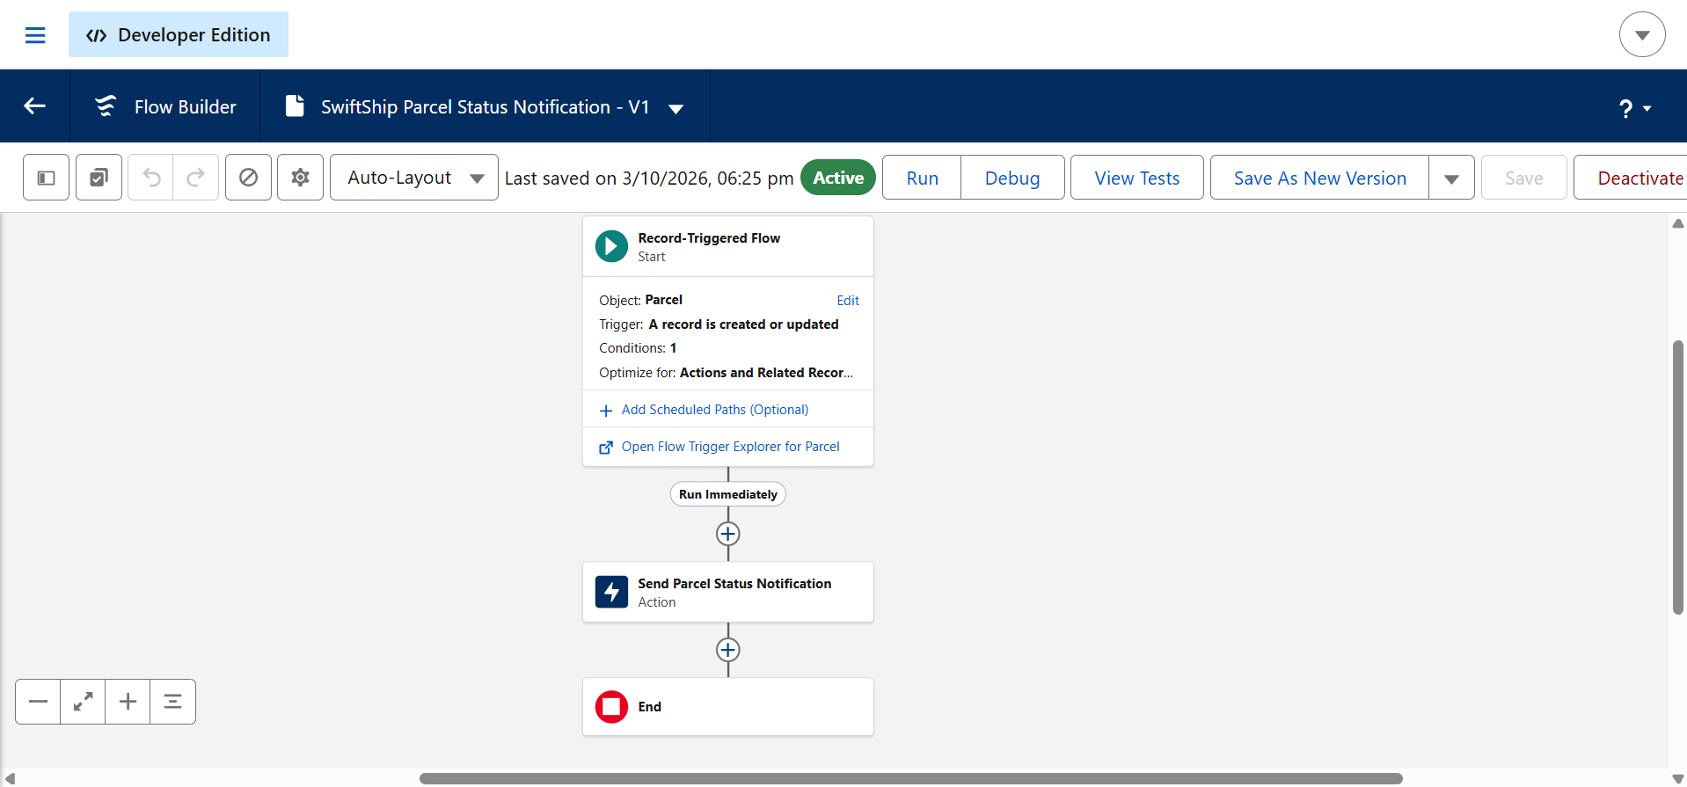
Figure 1: Parcel record PAR-00001 showing parcel details, status, receiver area, and estimated delivery.

7.2 Apex Trigger: ParcelDeliveryEstimateSyncTrigger
The Apex trigger ParcelDeliveryEstimateSyncTrigger runs after updates on Parcel__c. It detects changed estimated delivery dates on parcels and supports synchronization of the estimate to related delivery records.

7.3 Apex Batch: SwiftShipDeliveryEstimateSyncBatch
The batch class SwiftShipDeliveryEstimateSyncBatch finds Delivery records whose Estimated_Delivery__c differs from the parent Parcel's estimate and corrects those values. Its unit test, SwiftShipDeliveryEstimateSyncBatchTest, passes with 1 test and 0 failures.
A debugging challenge occurred when an earlier implementation failed with “fields being inaccessible on Sobject Delivery__c”. The issue was resolved by updating each record through a minimal new Delivery__c record containing only the Id and Estimated_Delivery__c, using Database.update with per-record error logging.

7.4 Flow: SwiftShip Parcel Status Notification
SwiftShip Parcel Status Notification is an active record-triggered flow. It runs when a Parcel is created or updated and sends a status email. During the demonstrated configuration, the flow sends to a fixed test address rather than to the parcel's Receiver.
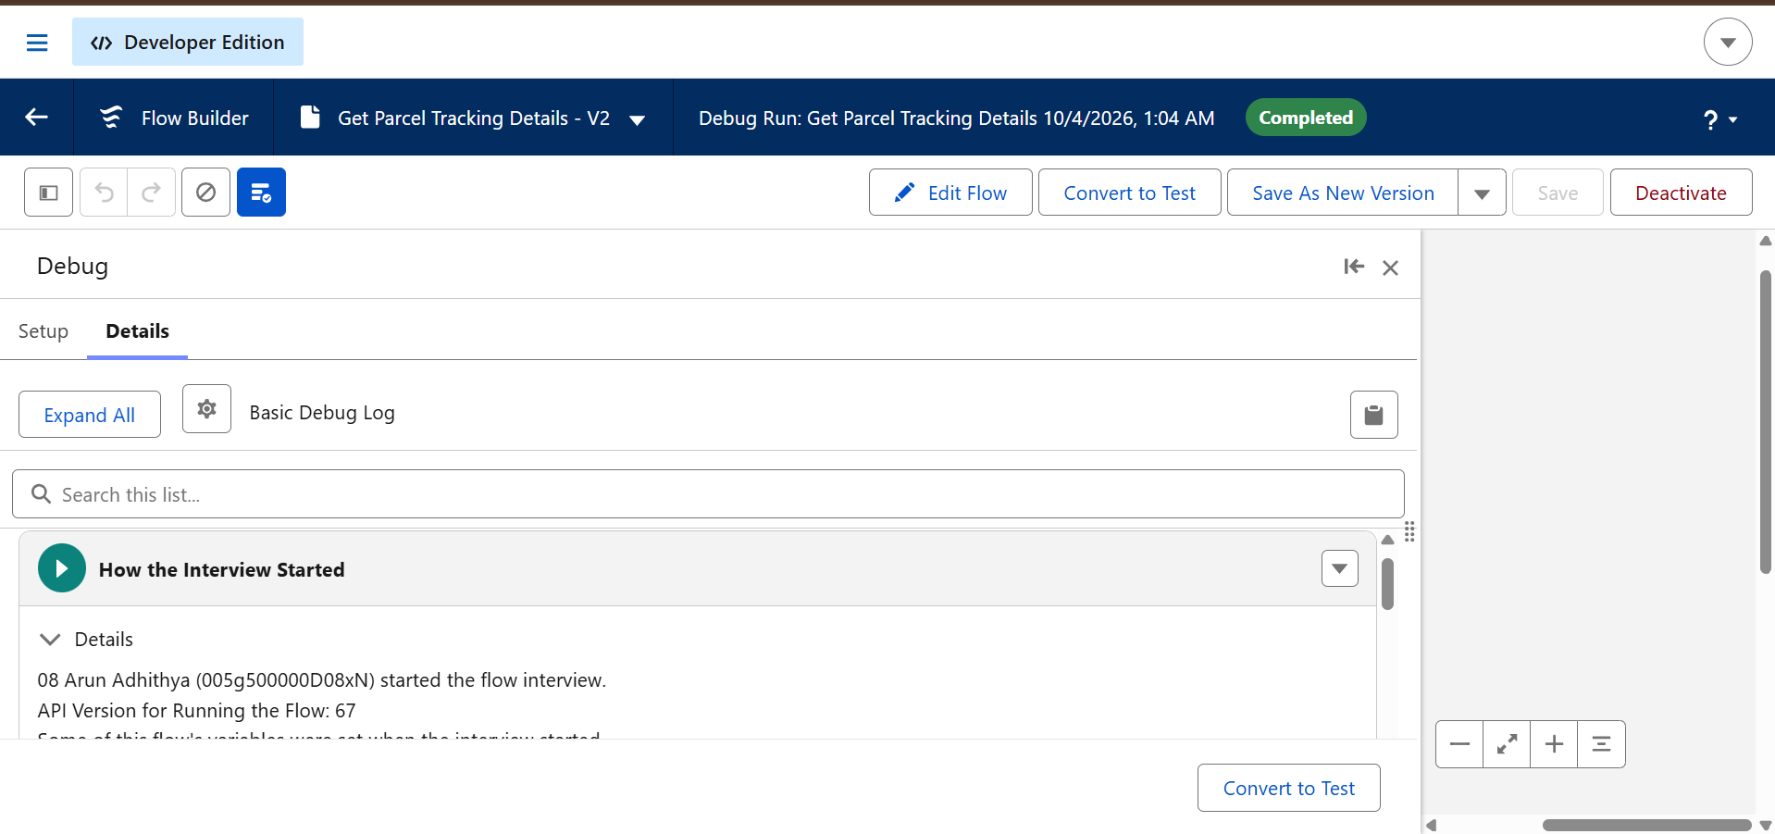
Figure 2: SwiftShip Parcel Status Notification record-triggered flow in Flow Builder.

7.5 Flow: Get Parcel Tracking Details (V2)
Get Parcel Tracking Details (V2) is an autolaunched flow. It takes the input ParcelNumberInput, retrieves the Parcel by Name using Get Records, and sets tracking outputs for status and estimated delivery. The flow was tested with Flow Builder's Debug tool using PAR-00001, and the run completed successfully.
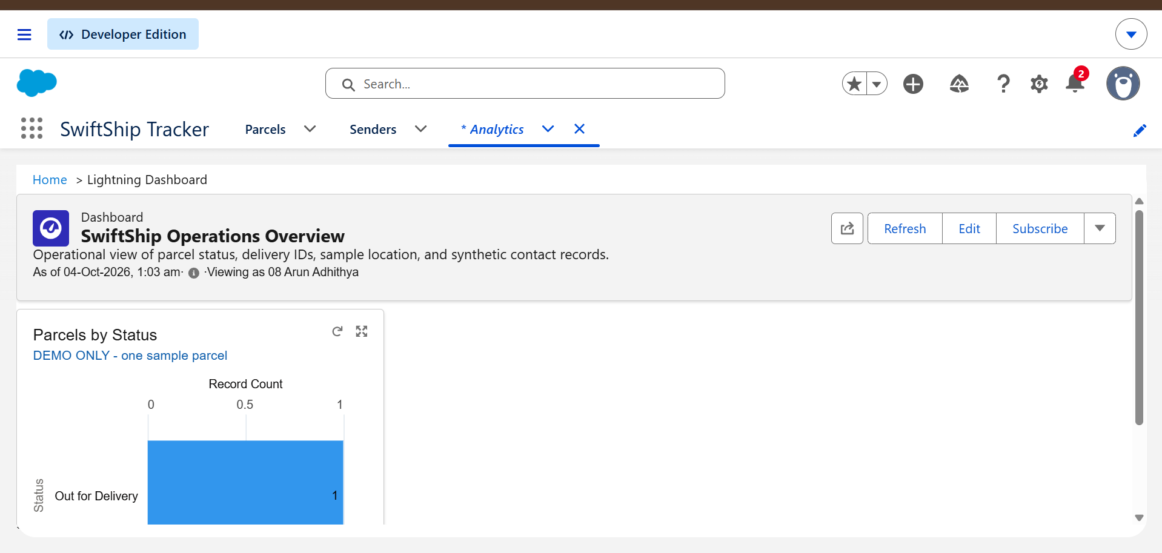
Figure 3: Get Parcel Tracking Details debug run showing the completed run and outputs.

7.6 Agent Parcel Updates Flow
An active flow named Agent Parcel Updates Flow exists to support agent updates. No further implementation details are described here.

7.7 Dashboard: SwiftShip Operations Overview
The SwiftShip Operations Overview dashboard provides an operational view of parcel status. It includes a Parcels by Status chart for monitoring parcel records by their current status.
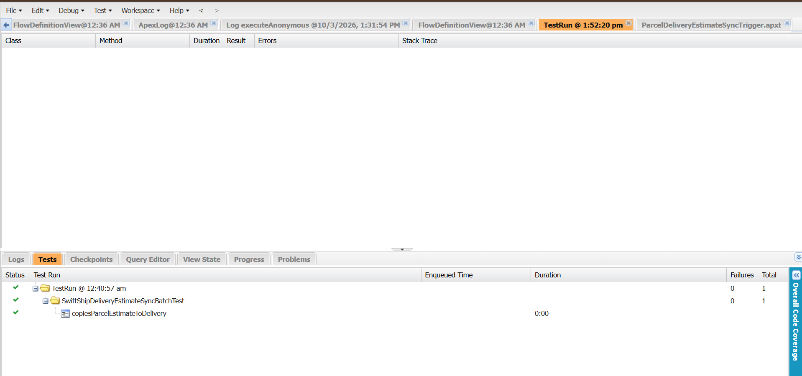
Figure 4: SwiftShip Operations Overview dashboard showing the Parcels by Status chart.

7.8 Security
An agent permission set and an operations report exist in the solution. The three personas—Customer, Agent, and Admin—are planned for role-based access, but full role-based access verification remains future scope.

8. Testing and Results
Test / Check | Result
Batch unit test | Passed (1 test, 0 failures).
Tracking flow debug run with PAR-00001 | Completed successfully.
Status change on parcel | The parcel record updates and triggers the notification flow.
Dashboard | Displays parcels by status.

Notification delivery requires an important qualification. During testing, delivery of the notification email to the inbox was not confirmed. Salesforce accepted a direct test email without error, but the message was not seen in the test inbox. Therefore, the notification is described as an implemented flow rather than as verified email delivery.

9. Challenges and Learnings
- Debugging the Apex batch DML failure and fixing it with minimal-record updates and per-record error handling.
- Working within limited time and tool access, so the scope was prioritised to an internal working flow.
- Learning Flow Builder debugging, Apex testing, and Salesforce email deliverability settings.

10. Limitations and Future Scope
- Notifications currently go to a fixed test address; the next step is sending them to each parcel's Receiver.
- There is no public customer portal because Digital Experiences was not enabled.
- Agentforce / an AI conversational agent for booking and tracking was planned but was not verified or completed.
- Role-based access for Customer, Agent, and Admin needs full verification.
- Future enhancements include live tracking updates, SMS notifications, and analytics.

11. Conclusion
SwiftShip Tracker demonstrates a Salesforce-based approach to parcel management using custom objects, status management, Flow Builder automation, Apex synchronization, tracking lookup, and operational reporting. The implementation provides an internal working flow for updating parcels, triggering status notifications, retrieving tracking details, and viewing parcel status through a dashboard. Testing confirmed the batch unit test and tracking-flow debug run, while email receipt was not confirmed and is therefore not presented as a verified result. The project establishes a foundation for future customer-facing capabilities, including receiver-specific notifications, a public portal, conversational AI, live tracking, SMS notifications, analytics, and fully verified role-based access.

12. References
Salesforce Trailhead and Salesforce documentation covering Flows, Apex, Reports, and Dashboards.

